Leaking Memory Monitor Module

The purpose of this module is to Test the behavior of the kernel when it leaks memory.

The code written is the looks like follow:

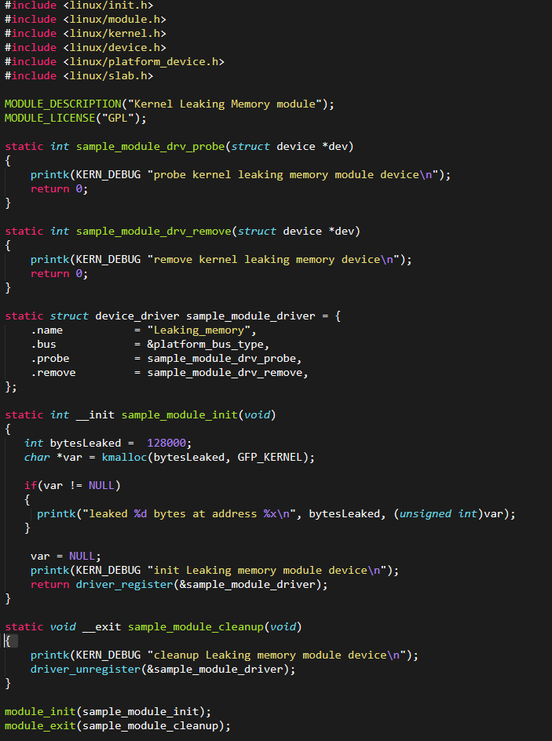

Every time the module reach 128000 bytes of memory leaked it will display the met value in the kernel messages log.

After write the code we need to create a Makfile with the obj-m := mdl.o to be able to build our kernel module.

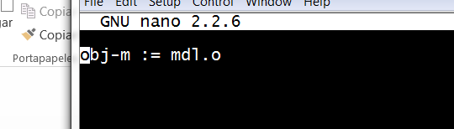

Using the instruction ***make -C /lib/modules/$(uname -r)/build M=$(pwd) modules*** for build the module.

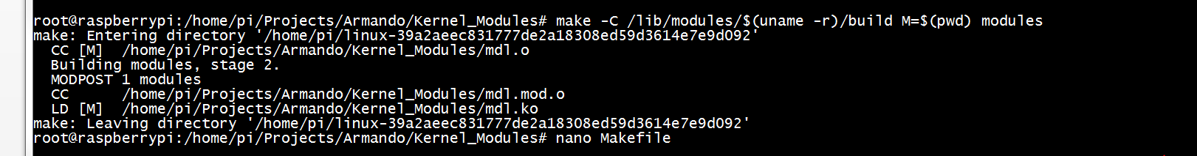

A kernel object will be created with the extension *.ko

Perform insmod to install the kernel module in the running kernel and then use dmesg command to see the kernel messages

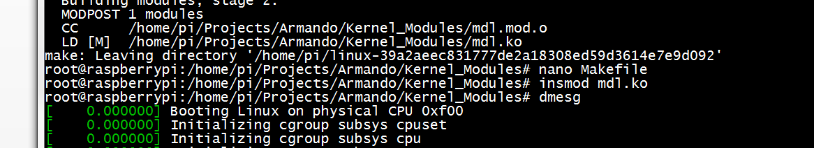

The physical address where the memory was leaked will be showed in the log.

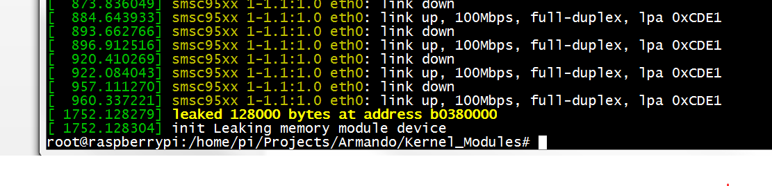

O remove the program module from the Linux kernel we use rmmod command.

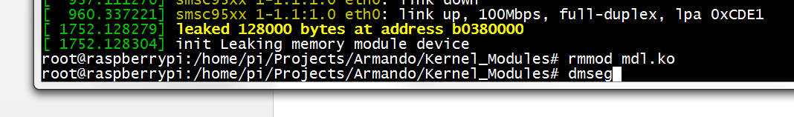



Dmesg command to see the kernel log:



Example of two different physical address with memory leaking